Lexical–gustatory Synesthesia

👅🧠 What is Lexical–Gustatory Synesthesia?
# Source: AI Source: Provided by: [Data Path: Persons Table -> ID Column: 1, Name_En Column: Motasem Essam] -> From: [Chatgpt (GPT-4-turbo)] on [7/24/2025]
Lexical–gustatory synesthesia is a rare type of synesthesia in which hearing, reading, or thinking about words (lexical stimuli) causes a person to experience specific tastes or flavors (gustatory responses), even though no food is present.

📘 Definition:
# Source: AI Source: Provided by: [Data Path: Persons Table -> ID Column: 1, Name_En Column: Motasem Essam] -> From: [Chatgpt (GPT-4-turbo)] on [7/24/2025]
Lexical–gustatory synesthesia is a neurological condition where words or sounds involuntarily trigger taste sensations.

🍽️ Example Experiences:
# Source: AI Source: Provided by: [Data Path: Persons Table -> ID Column: 1, Name_En Column: Motasem Essam] -> From: [Chatgpt (GPT-4-turbo)] on [7/24/2025]
- Hearing the word "table" might trigger the taste of scrambled eggs.
- Saying the name "Michael" might produce a minty flavor.
- Thinking of numbers or days of the week may evoke flavors like chocolate or vinegar.
These taste experiences are consistent for the synesthete over time.

🔍 How It Works:
# Source: AI Source: Provided by: [Data Path: Persons Table -> ID Column: 1, Name_En Column: Motasem Essam] -> From: [Chatgpt (GPT-4-turbo)] on [7/24/2025]
- Lexical = related to words
- Gustatory = related to taste
- The language-processing areas of the brain are cross-wired with taste-processing areas.
- The result: a person literally "tastes" words — not metaphorically, but neurologically.

🧬 Scientific Notes:
# Source: AI Source: Provided by: [Data Path: Persons Table -> ID Column: 1, Name_En Column: Motasem Essam] -> From: [Chatgpt (GPT-4-turbo)] on [7/24/2025]
- Extremely rare — affects fewer than 1 in 100,000 people.
- Tastes may be complex (e.g., cinnamon toast) or basic (e.g., bitter).
- Some people also report mouthfeel (texture) and temperature.
- The experience is not under voluntary control and not imaginary — brain imaging confirms cross-activation in synesthetes.

🔄 Related Types of Synesthesia:
# Source: AI Source: Provided by: [Data Path: Persons Table -> ID Column: 1, Name_En Column: Motasem Essam] -> From: [Chatgpt (GPT-4-turbo)] on [7/24/2025]
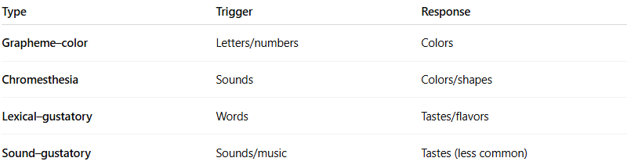
Type | Trigger | Response
Grapheme–color | Letters/numbers | Colors
Chromesthesia | Sounds | Colors/shapes
Lexical–gustatory | Words | Tastes/flavors
Sound–gustatory | Sounds/music | Tastes (less common)

✅ Summary:
# Source: AI Source: Provided by: [Data Path: Persons Table -> ID Column: 1, Name_En Column: Motasem Essam] -> From: [Chatgpt (GPT-4-turbo)] on [7/24/2025]
Lexical–gustatory synesthesia is when a person tastes specific flavors in response to hearing, reading, or thinking about words.
It’s involuntary, consistent, and neurologically real — a fascinating example of how the brain blends sensory information.

